

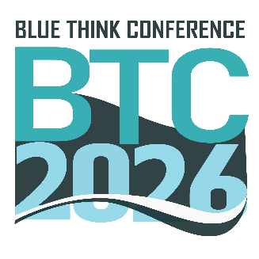
Template for submitting an abstract for BTC2026
Name Surname¹, Name Surname² and Name Surname
¹Department/Investigation Team, Faculty/Research Center initials – Faculty/Research Center in full, University, City, Country, ²Department/Investigation Group, Faculty/Research Center initials – Faculty/Research Center in full, University, City, Country
E-mail: presenting author email

The title should be centered, using a 14 pt Arial font, bold, with a multiple 1.25 lines spacing.
The name(s) of the author(s) (first name and family name) should be centered, using a 12 pt Arial font, regular, with a multiple 1.25 lines spacing. Please do not abbreviate names. The name of the presenting author should be underlined. Use number superscripts to indicate different affiliations, do not include addresses.
The e-mail address of the presenting author should be centered, using 10 pt Arial font, italic, with a multiple 1.25 lines spacing.
The abstract must not exceed one A4 page max (including references and acknowledgments), with 2.5 cm margin on each side. The text of the abstract should be justified, using 12 pt Arial font, regular, with a multiple 1.25 lines spacing and first line indentation 1.25 cm. Save your document in a word file and name it.
References, when present, should be using 10 pt Arial font, regular, with a multiple 1.25 lines spacing and should be indicated by superscript Arabic numbers following the citation order: example ^{1,2}. Abstracts will be reproduced in the Book of Abstracts in this style. Please ensure that all links are removed prior to saving and sending the abstract. All abstracts must be saved in .doc or .docx format and named using Surname_Name_BTC2026. The file is to be submitted through this link.

[1] Author, Author, Author, Author, Journal, year, vol, page–page.
[2] Author, Author, Author, Author, Journal, year, vol, page–page.
Acknowledgments: Acknowledgments should be using 10 pt Arial font, regular, with a multiple 1.25 lines spacing.

